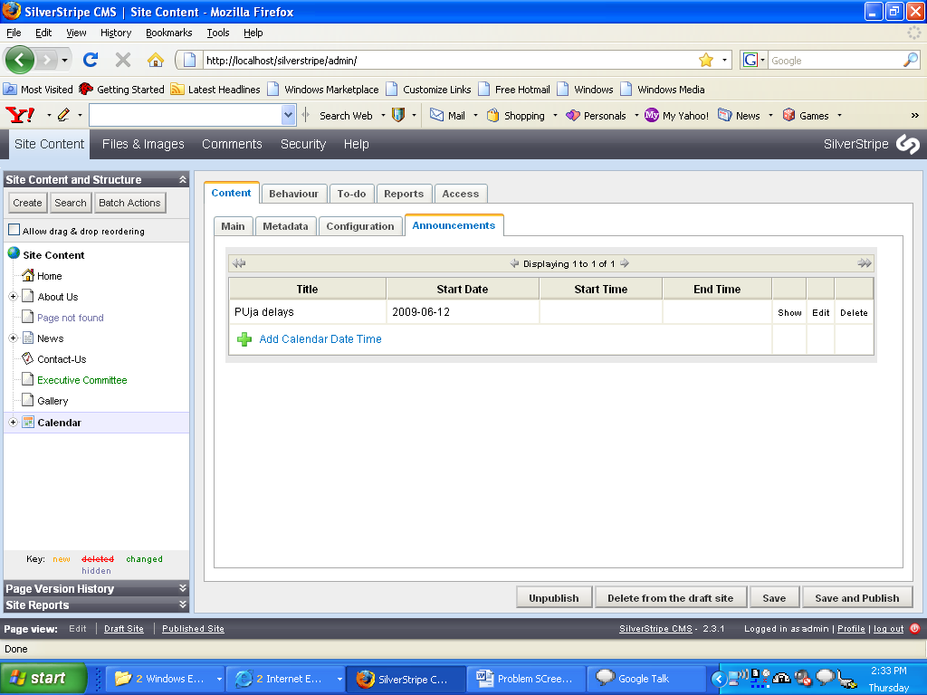

In this screen show, edit and delete are not working. When I try to click edit button, there is no response.

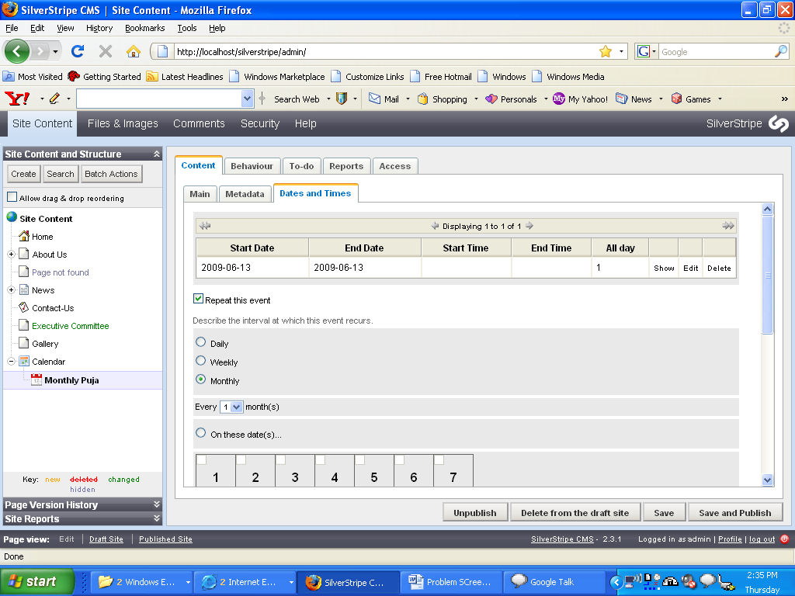

In this screen show, edit and delete are not working. When I try to click edit button, there is no response.

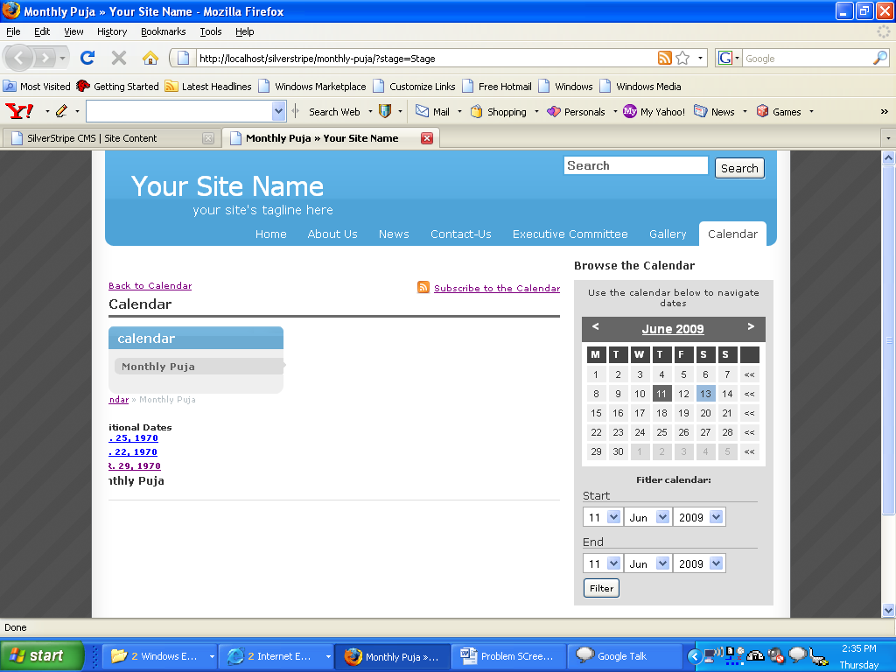

Please notice the left hand side of the event description. There is no alignment.
And can I add detailed description with event?

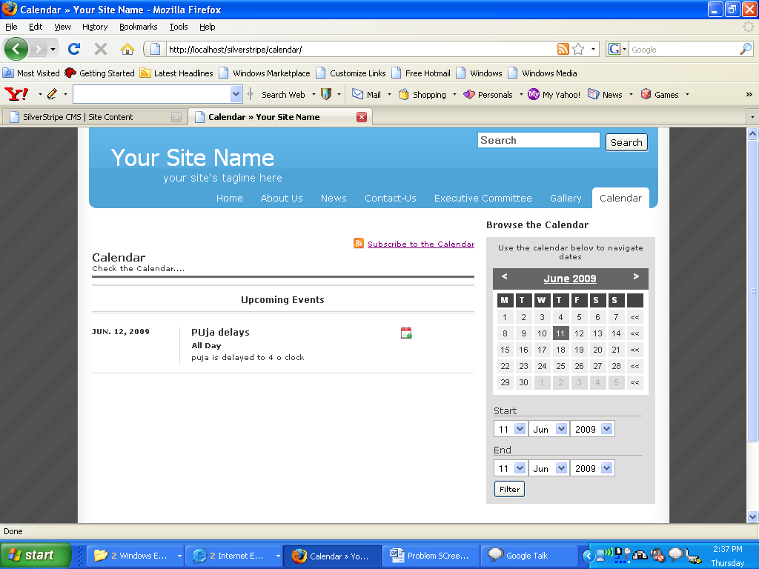

From this screen, if I refresh the screen I obtain the same page.
There is no link where I can go to the event details added. Also I tried clicking the dates but no change.

